How to contribute to Our Welwyn Garden City

Type the website address
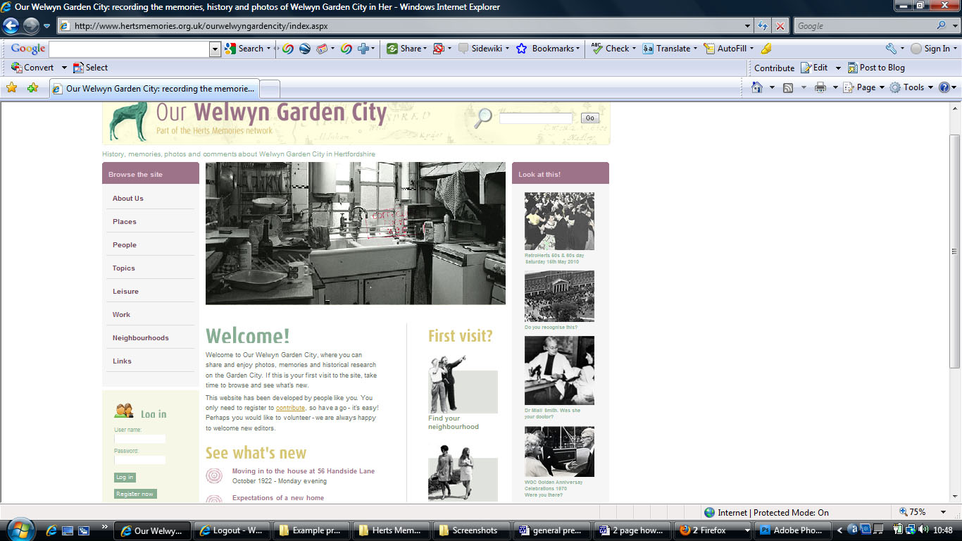
www.hertsmemories.org.uk/ourwelwyngardencity
into your browser’s address bar

Register

To add your contributions you need
to register

Click on the ‘Register now’ button

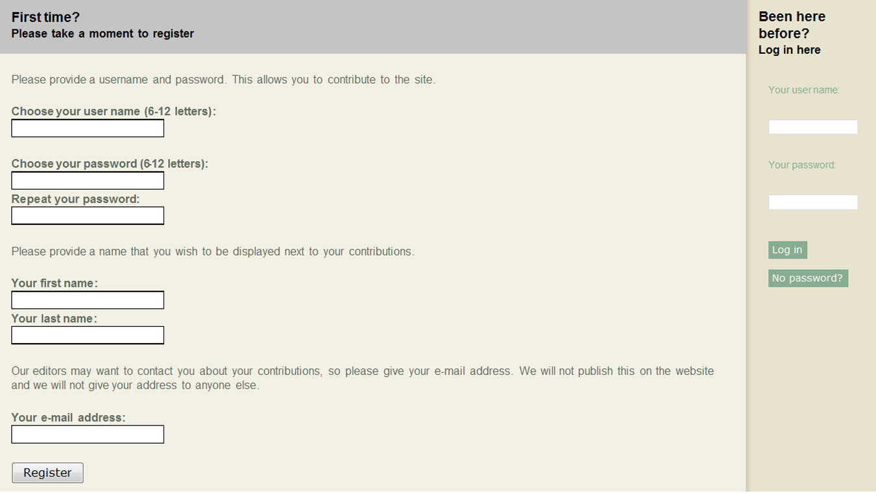
Choose a user name
(this could be your first name)

Choose a password you will remember

Enter your first and last names as you
wish them to appear by your contribution

Enter your email address

Finally, click on the ‘Register’ button
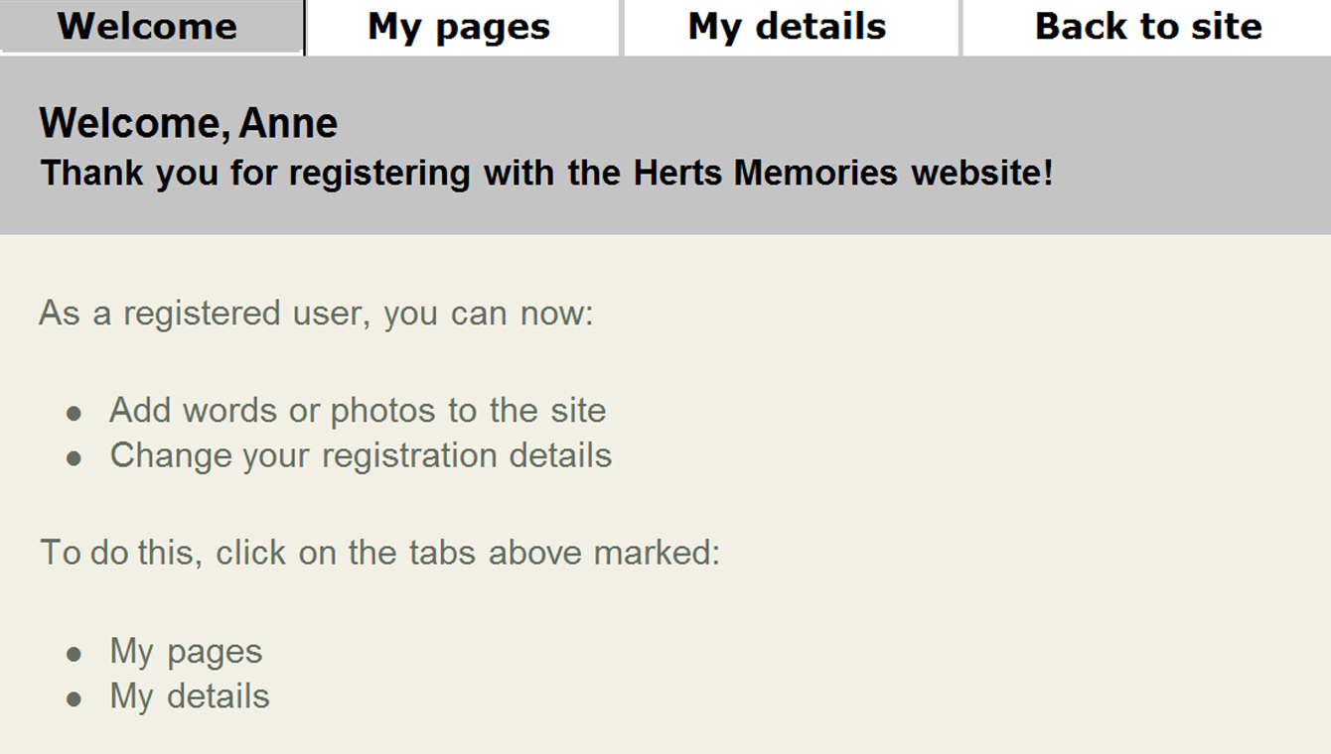
You will then reach the welcome screen:

Click on the ‘My pages’ tab then click on
‘Add a page’ to start work on a new page
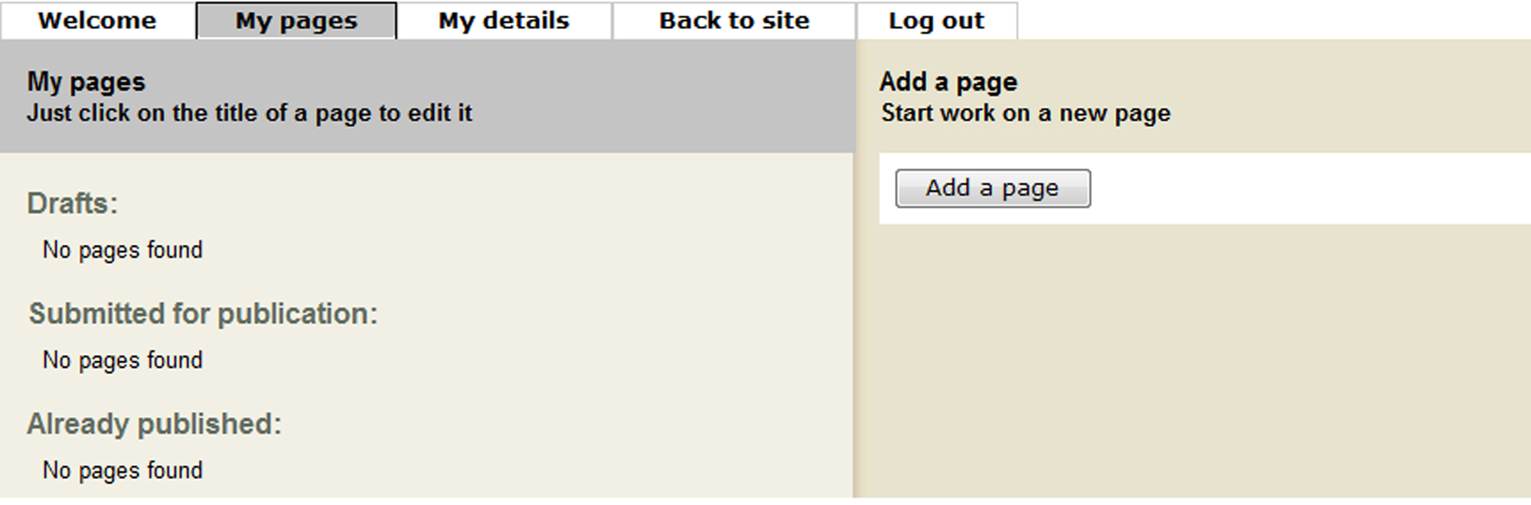

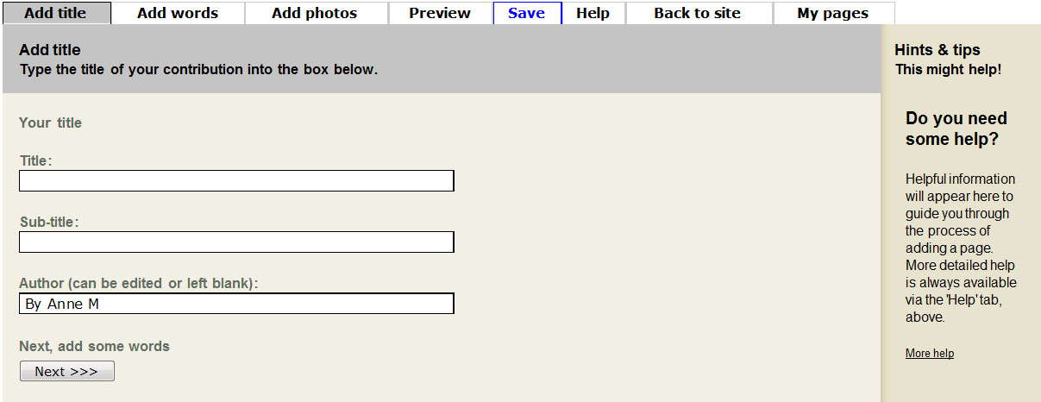
Add title

Type in the title of your article

Add a subtitle if you would like to

Your name automatically appears in this box
(you can edit it if you wish)

Use the ‘Next’ button to move to the
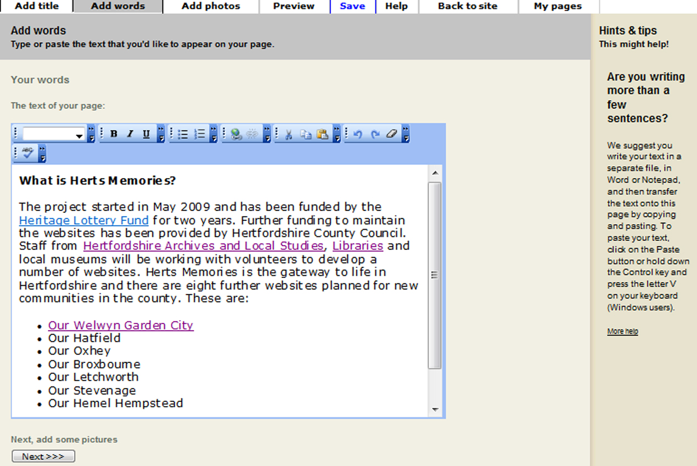
next screen

Add words

You can type straight into the box or cut and
paste from your computer/memory stick

There are hints and tips on the right hand
side or you can click on ‘Help’ for more
advice

You can add headings, links to other web
pages, lists and more.

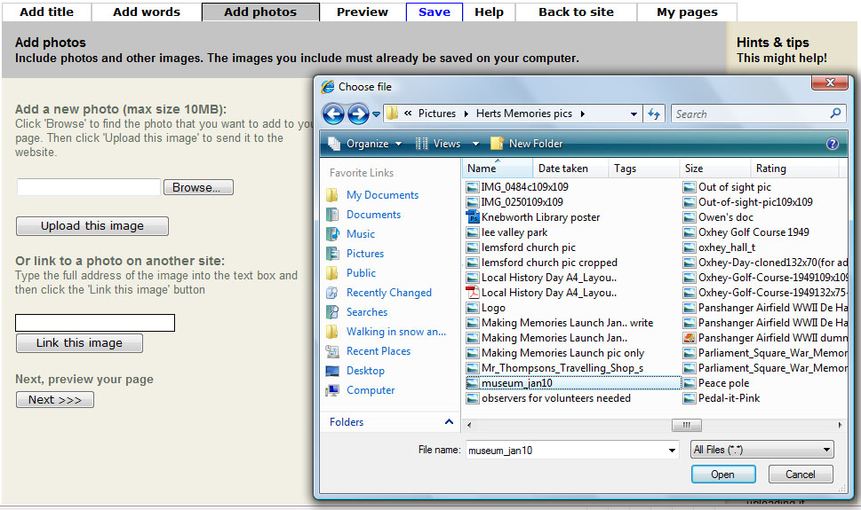
Add photos

Now you can add your photos or other
pictures. The images must be on your
computer or on a memory stick

Click on the ‘Browse’ button to find the
image you want. A new window will appear.
Select the image and click on ‘Open’.
The file address of the image will appear
in the box.

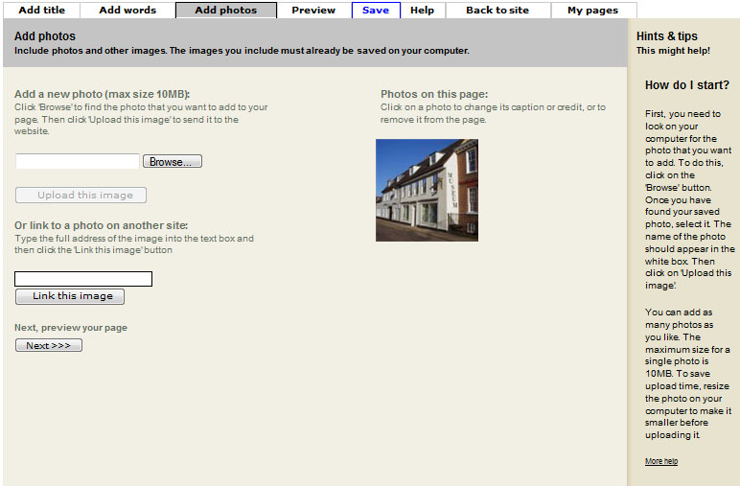
Click on ‘Upload this image’

The image you have chosen will appear on
the page (not full size)

You can add as many pictures as you like
(each image must be less than 10MB)

Click on the image to add a caption

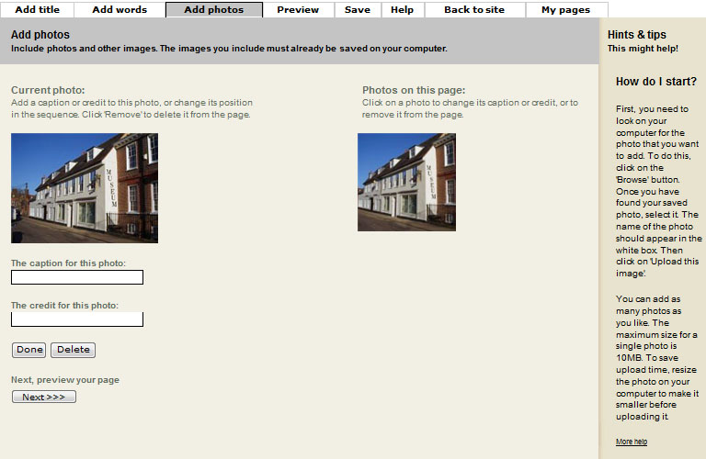
Write your caption in the box

You can also add a credit for the photo
(who took it or who owns the copyright)

From this screen you can also delete
an image from the page by clicking
on ‘Delete’

Click on ‘Done’ to confirm changes

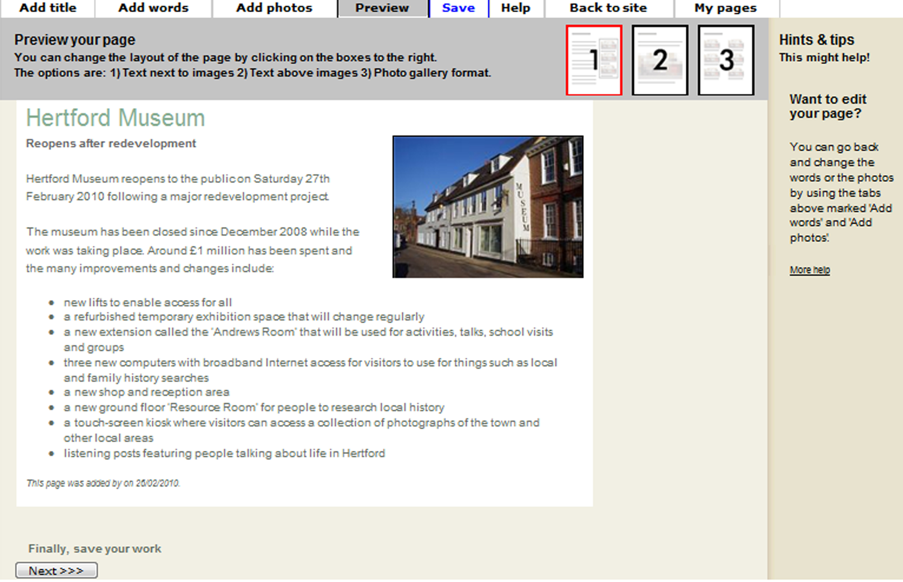
Preview

Click on the preview tab to see what the
article will look like when published on the
website and choose the best layout

The standard layout is shown here

You can try out alternative layouts by
clicking on the numbered buttons

Save

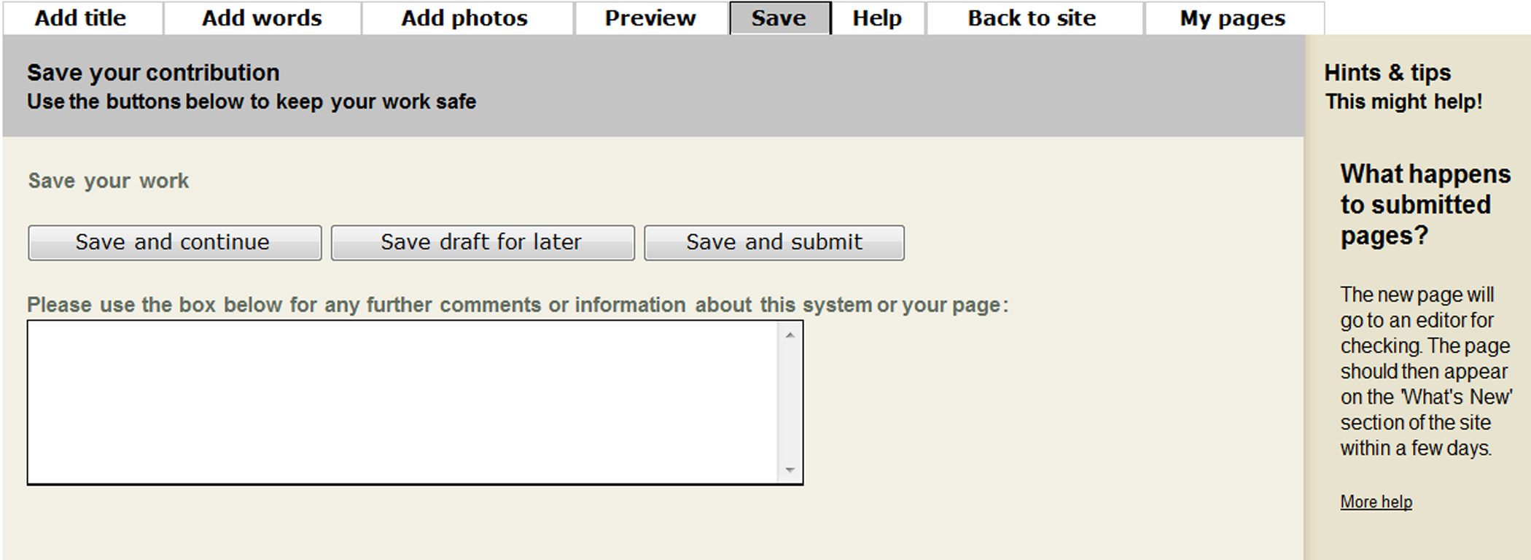
When you are happy with how your
page looks, you can save it

If you would like to come back to your page
later on click on ‘Save draft for later’.
If your page is ready to be published click
on ‘Save and submit’

