Welwyn Roman Baths: Heritage Site Report

By Rachael Hendricks, University of Hertfordshire Student.

Annotated Bibliography

Primary Sources

Oxley, Jenny, ‘Welwyn Roman Baths’ Photograph, Welwyn Hatfield Museum Service (2010), https://www.ourwelwyngardencity.org.uk/content/links/welwyn-hatfield-museum-service, Accessed 12th March.

This modern photograph captures the Roman baths from the entrance of the steel vault. It depicts a raised walkway surrounding the ruins from a birds eye perspective. It can be utilised to demonstrate how well-preserved, yet fragile, the baths are, emphasising the importance of protectionist schemes coordinated by the Welwyn Archaeological Society. The image represents significant change to the site since 1960. It shows the positive transformation; from desolate and crumbling to lit, accessible and under protection.

Rook, Tony, ‘Lockleys to Digswell’, River Mimram (2014), no pages available.

Published in 2014, Rook records tracking the River Mimram through Hertford and Welwyn Garden City. It is an exceptional primary source because Rook led the ground-breaking excavation of the Roman baths in 1960. He provides an insightful account, adding value with personal recollections. He discusses the creation of Welwyn as a Garden city surrounding the River and above the baths. This perspective emphasises the baths’ value to the unique heritage of Welwyn’s establishment.

Secondary Sources

Quinn, Tom, ‘Britain’s Best Historic Sites: From Prehistory to the Industrial Revolution’, Welwyn Bath House (Fox Chapel Publishing, 2013), no pages available.

Quinn examines a collection of historic sites across Britain, including Welwyn Roman Baths. He comments the ‘well- preserved hypocaust heating system’ was ‘central’ to the Roman villa and shows the popularity of bathing at the time. Quinn can be utilised because he provides a summarising account of what can be found at the site and moreover, posits the idea the Roman baths are important as part of the wider narrative of Britain’s Roman heritage.

The Welwyn Garden City Heritage Trust website, About Us, http://www.welwyngarden-heritage.org/about-us, Accessed 4th March 2020.

This website is the hub of Welwyn organisation, documenting discovery, preservation and changes to the heritage of Welwyn Garden City. It usefully highlights its aims and objectives as a trust organisation and therefore, its intentions towards the use and protection of the Roman Baths. It demonstrates the importance of organisational efforts in promoting community values and acts as an archive of Welwyn’s history.

One Welwyn Hatfield Borough Council website, Welwyn Roman Bath secures National Lottery funding, https://one.welhat.gov.uk/RomanBathslotteryfund, Accessed 4th March 2020.

This article boasts of the grant awarded by the National Lottery Heritage Fund to the ‘What’s Under Our Feet?’ archaeological dig in support of the Roman Baths. It not only shows the national support towards excavation but recognises the baths as a valued creator of civic pride and community involvement. Led by the Welwyn Archaeological Society, aspiring archaeologists will participate in surveying the baths. This can be utilised to understand how the baths create a thriving environment for community involvement in the preservation of Welwyn’s heritage.

Heritage Site Report

In 1960, Tony Rook and his wife led a group of volunteers to excavate surrounding the River Mimram in Welwyn. Tony recalls walking approximately 150 metres in the river when he noticed Roman tiles protruding from the soil. This was soon to become part of the much wider Dicket Mead Roman villa. Ongoing construction of the A1(M) threatened archaeological potential, so Tony and the team used machinery to remove the soil, unveiling a suite of 3rd century Roman baths. They lobbied local authorities and successfully drew plans to create a protective steel vault. This progress is documented in Tony’s own book ‘River Mimram’ published in 2014. It highlights the significant transformation of the Roman baths; from near demolishment to the effort to uncover and protect, bringing the site into light. The team reorganised themselves into the Welwyn Archaeological Society.

The entrance descends below surface level underneath the A1(M). This itself, is remarked as an interesting experience; specific to the heritage of Welwyn in the storytelling of Roman-Britain. A surrounding walkaway overlooks the site; a well-preserved hypocaust system with accompanying tepid, hot and cold rooms. This is can be seen in Image 1. The walkway, lighting and information boards are added features to showcase the baths to their full potential. This change has improved public accessibility and understanding. The suite is categorised as a scheduled moment as part of the Dicket Mead Roman villa. This means that the site is considered of national importance; vulnerable and valuable.

The spirit of the baths relies on imagination. To fulfil the atmosphere, we must picture how the baths were used and by who. Applying this concept, enhances the value of the site through understanding the baths as a social place of interaction and relaxation. Even though the baths no longer function, the site still brings people together through learning. This demonstrates the continuation of the spirit yet the change in use. A first century skeleton of a Welwyn woman is displayed in a glass cabinet. Implying a connection between the audience and Roman predecessors creates a unique marketing tool and value to the people of Welwyn Garden City.

Image 1:

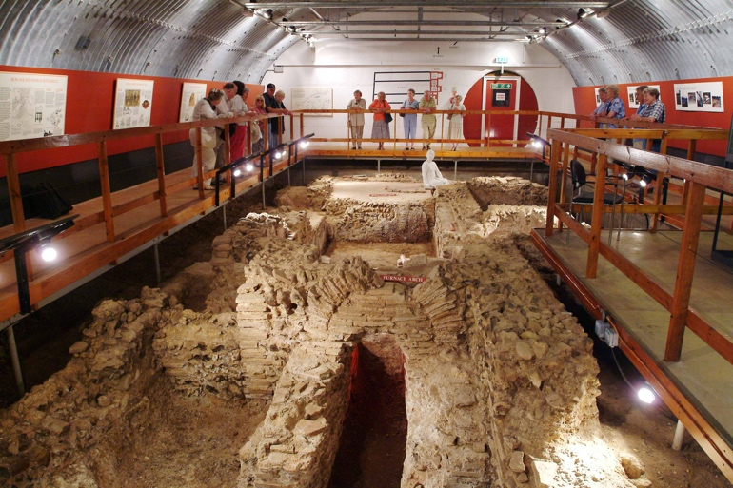

The Welwyn Archaeological Society plays a central role in the preservation and promotion of heritage sites for the benefit of Welwyn community. It praises Tony and Merle Rook as founders but names its new director as Dr Kris Lockyear, who continues to promote the organisation’s legacy. The aims and objectives of the organisation coincide with those of Welwyn Garden City Heritage Trust; ‘to promote a sense of civic pride’ and involvement. The Society and Trust fund demonstrate the importance of public sector organisations who carry the responsibility and influence to protect and promote heritage sites by caring for what people value. Prominent interest will encourage active community involvement.

The National Lottery Heritage awarded a £9,600 grant to the Society in promotion of the ‘What’s Under Our Feet?’ project. This will use geographical survey techniques to understand the structure beneath the baths. As the scheme progresses, our knowledge, accessibility and the site itself will change. This is a change yet to come but hopefully will see the site flourish despite its age. Kate Clark usefully acknowledges ‘good conservation is not about stopping change but about managing it in a way that does not destroy the past’. The project is a good example of managing protection whilst expanding the baths and avoiding damage. Ka Ng, Corporate Director at Welwyn Hatfield Borough Council, commented:

‘We are really pleased to have received this support thanks to the National Lottery Heritage Fund, and we can’t wait to get to work sharing the heritage of Welwyn Roman Baths with the Young Archaeologists Club, and expanding our understanding of what life was like in Welwyn Hatfield over 1,800 years ago.’

This shows recognition of the Roman Baths as a valuable site to Welwyn with the utility to involve the younger generations in excavation work. The sense of civic pride pushed the site into national perspective as the attention warranted a substantial fund by the National Lottery. Such financing will bring together people from older and younger generations, fulfilling the objectives of Welwyn Heritage Trust to further knowledge and engender pride.

Critical Reflection

Investigating the Roman Baths has improved my ability to organise and conduct research. It was challenging to sort through the abundance of material to find the most appropriate sources. Nevertheless, through comparison of usefulness I eliminated sources which did not explain how the baths are valuable or have changed. Following the assessment guidelines meant my research did not stray into other topics.

In order to produce a comprehensive site report, I had to breakdown the points made by Kate Clark in her value assessment guide. It was really important I understood not only the physicality of the Roman baths but how they are valued and managed. Using her work, I was able to understand the importance of organisations, the spirit and community as well as national interest in the Roman baths. Although this required additional reading, Clark’s information helped create a report which emphasised the value of the Roman baths as part of Welwyn’s wider heritage.

The biggest challenged I faced was the 1500-word count. The restriction obviously limited what I could say so I thought carefully about each sentence and questioned if it added content or analysis. I developed the ability to decipher between good and useful work. I understood although what I wrote was interesting, if it was not relevant to the value or change of the site, it had to be excluded in favour of content that answered the site report questions. This links closely to the skills I developed when researching. Applying this strict method, I adhered to the word count whilst feeling I had covered everything the assignment asked for.

Bibliography

Clark, Kate, ‘Value-Based Heritage Management and the Heritage Lottery Fund in the UK’, APT Bulletin: The Journal of Preservation Technology, Vol. 45, No. 2/3 (Association for Preservation Technology International, 2014), pages 65-71.

Historic England, ‘Dicket Mead Roman villa’, https://historicengland.org.uk/listing/the-list/list-entry/1015580 (2020), Accessed 12th March.

One Welwyn Hatfield Borough Council website, ‘Welwyn Roman Bath secures National Lottery funding’, https://one.welhat.gov.uk/RomanBathslotteryfund, Accessed 4th March 2020.

Oxley, Jenny, ‘Welwyn Roman Baths’ Photograph, Welwyn Hatfield Museum Service (2010), https://www.ourwelwyngardencity.org.uk/content/links/welwyn-hatfield-museum-service, Accessed 12th March.

Quinn, Tom, ‘Britain’s Best Historic Sites: From Prehistory to the Industrial Revolution’, Welwyn Bath House (Fox Chapel Publishing, 2013), no pages available.

Rook, Tony, ‘Lockleys to Digswell’, River Mimram (Amberly Publishing Limited, 2014), no pages available.

Ross, David, ‘Welwyn Roman Baths’, Britain Express (1996), https://www.britainexpress.com/counties/herts/roman/welwyn-roman-baths.htm, Accessed 12th March

The Welwyn Archaeological Society, ‘History of the Society’, https://welwynarchaeologicalsociety.wordpress.com/history-of-the-society/, Accessed 12th March.

The Welwyn Garden City Heritage Trust website, ‘About Us’, http://www.welwyngarden-heritage.org/about-us, Accessed 4th March 2020.

Tony Rook, ‘Lockleys to Digswell’, River Mimram (Amberly Publishing, 2014), no page.
Rook, River Mimram.
Rook, River Mimram.
Rook, River Mimram.
Rook, River Mimram.
Rook, River Mimram.
Tom Quinn, ‘Welwyn Bath House’, Britain’s Best Historic Sites: From Prehistory to the Industrial Revolution (Fox Chapel Publishing, 2013), no page.
Quinn, Best Historic Sites (2013).
Quinn, Best Historic Sites (2013).
Jenny Oxley, Welwyn Roman Baths Photograph, Welwyn Hatfield Museum Service (2010), https://www.ourwelwyngardencity.org.uk/content/links/welwyn-hatfield-museum-service, Accessed 12th March.
‘Dicket Mead Roman villa’, Historic England, https://historicengland.org.uk/listing/the-list/list-entry/1015580 (2020), Accessed 12th March.
Kate Clark, ‘Value-Based Heritage Management and the Heritage Lottery Fund in the UK’, APT Bulletin: The Journal of Preservation Technology, Vol. 45, No. 2/3 (Association for Preservation Technology International, 2014), page 69.
David Ross, ‘Welwyn Roman Baths’, Britain Express (1996), https://www.britainexpress.com/counties/herts/roman/welwyn-roman-baths.htm, Accessed 12th March.
The Welwyn Archaeological Society, https://welwynarchaeologicalsociety.wordpress.com/history-of-the-society/, Accessed 12th March.
‘History of the Society’, The Welwyn Archaeological Society, https://welwynarchaeologicalsociety.wordpress.com/history-of-the-society/, Accessed 12th March.
‘About Us’, The Welwyn Garden City Heritage Trust, https://welwynarchaeologicalsociety.wordpress.com/history-of-the-society/, Accessed 12th March.
Clark, Journal of Preservation Technology, page 68.
‘Welwyn Roman Baths secures National Lottery funding’, One Welwyn Hatfield, https://one.welhat.gov.uk/RomanBathslotteryfund, Accessed 12th March.
One Welwyn Hatfield, https://one.welhat.gov.uk/RomanBathslotteryfund, Accessed 12th March.
Clark, Journal of Preservation Technology, page 68.
One Welwyn Hatfield, https://one.welhat.gov.uk/RomanBathslotteryfund, Accessed 12th March.
The Welwyn Garden City Heritage Trust, https://welwynarchaeologicalsociety.wordpress.com/history-of-the-society/, Accessed 12th March.
Clark, Journal of Preservation Technology, page 69.

